|  |  |  |  |
| --- | --- | --- | --- |
| \\lyng-dc1\StaffShared\Learning Bugs Animals ALL subjects\characters bugs animals\Cyril the Snail - History.jpeg**Lyng Primary School Knowledge Organiser** | | | |
| **History Topic:** | **WWI** | Year 6  *Civilisation, Communication and Inventions* | Summer Term |

**Trip/ Visit**

Trench life –

Forest school trenches.

**Milestone 3 Objectives that we will be covering this term.**

**Investigate:**- Use sources of evidence to deduce information about the past.  
- Show an awareness of the concept of propaganda and how historians must understand the social context of evidence studied.

**Build an Overview of World History:**  
- Give a broad overview of life in Britain and some major events from the rest of the world.  
-Describe the social, ethnic, cultural or religious diversity of past society.  
- Describe the characteristic features of the past, including ideas, beliefs, attitudes and experiences of men, women and children  
- Compare some of the times studied with those of other areas of interest around the world

**Chronology**:  
- Describe the main changes in a period of history (using terms such as: social, religious, political, technological and cultural).  
- Identify periods of rapid change in history and contrast them with times of relatively little change.

|  |  |
| --- | --- |
| **What Step On and Goldilocks words will I use?** | |
| **Spelling** | **Definition** |
| Alliance | When countries join forces or work together to achieve a common goal. |
| Annexed | To take and rule over land without permission. |
| Armistice | A formal agreement where warring parties agree to stop fighting. |
| Assassinate | To murder an important person for political or religious reasons. |
| The Black Hand | Serbian terrorist society who used violence towards political powers in an attempt to liberate (free) Serbia. |
| Central Powers | The countries who fought against the allied nations. |
| Conscription | The requirement by law to join the armed forces. |
| Front Line | The area where armies engage in fighting. |
| The Great War | The name used for World War One at the time. |
| Imperialism | A country expanding its power across an empire |
| League of Nations | A worldwide intergovernmental organisation with the aim of keeping world peace. |
| Militarism | Competition between countries over military power |
| Nationalism | Intense patriotism and loyalty to a person’s own country. |
| No Man’s Land | The area of land between to enemy trench systems. |
| Treaty | A written agreement between two or more countries. |
| Trench | Long ditches dug into the ground where soldiers live for the duration of the campaign. |



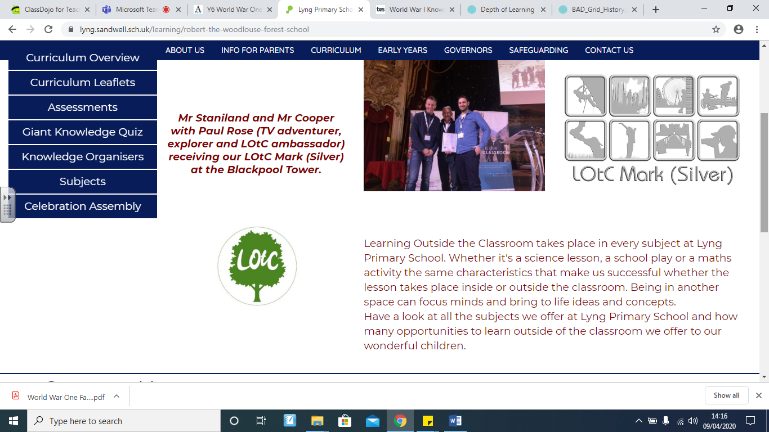

|  |  |
| --- | --- |
| Assassination of Franz Ferdinand - World War 1 - History for Kids**Arch Duke Franz Ferdinand (1863-1914)**  The assassination of Franz Ferdinand (Archduke of Austria) contributed to the outbreak of World War One. Archduke Franz Ferdinand of Austria was the Prince of Hungary and Bohemia. When he rose to power, he wanted to try and make the gap between rich and poor smaller. However, people in power did not agree with him. The Black Hand eventually successfully assassinated him and his wife in 1914.This led to war between Austria-Hungary and Bosnia. | **Kaiser Wilhem II (1859 – 1918)**  Wilhelm II, German Emperor - Wikipedia Wilhelm was the German Emperor who policies led to the country’s involvement in WWI. The Kaiser’s mother was Princess Victoria (Queen Victoria’s daughter); he was Queen Victoria’s grandson. Wilhelm had a volatile temper and had formed enemies in France and Russia. He also isolated himself from Britain by stated that the Germans didn’t like the British in an interview he had with the Daily Telegraph. Wilhelm agreed to support Austria-Hungary offering them a ‘blank check’ and an ally in war. When he realised Germany was on the brink of collapse, he abdicated the throne and fled to Netherlands. |
| **David Lloyd George (1863-1945)**  David Lloyd George - Wikipedia George was the Prime Minister of the UK from 1916. He joined parliament in 1890 and at the time was the youngest MP. He was vehemently against war; instead he worked tirelessly to establish a welfare state where the government helped the sick and poor. Upon hearing of Germany’s invasion of Belgium, George became one of the main powers of guiding Britain to war. His job at the beginning of the war was ‘Minister of Munitions’; he had to ensure that Britain was equipped for war. He was one of ‘The Big Three’ who drew up the Treaty of Versailles to end War. | **Woodrow Wilson (1856-1924)**  Woodrow Wilson - Wikipedia Wilson was the Presidant of USA during WWI. He helped form the League of Nations after the war ceased. When war broke out Wilson wanted to keep USA out of it; he had had bad experiences of war when he was growing up and didn’t want that for his country. After his second election, Germany started sinking U.S ships on their way to Britain so Wilson had no choice but to join the war. One of the his main reasons for helping in the war campaign was to restore Belgium after Germany had invaded. When the war ended Wilson received the Noble Peace Prize for his efforts in forming the League of Nations. |
| **Tsar Nicholas II (1868 – 1918)**  Tsar Nicholas II - Death, Wife & Family - Biography He was the Tsar of Russia during WWI. When he first took the throne in Russia he formed an alliance with France and proposed the Hague Peace Conference to keep peace in Europe. Nicholas’ government forced millions of Russian peasant to join the army during the war, many fought barefoot and weaponless. In 1917, the Russian people revolted and focred Nicholas to abdicate the throne – Vladimir Lenin took control of the army. Lenin’s Bolsheviks held the Tsar and his family prisoner and all were excuted. He was King George V’s cousin and Wilhelm’s 2nd cousin. His wife was Queen Victoria’s grandaughter. | Wilfred Owen - Wikipedia**Wilfred Owen (1893 – 1918)**  He was born in Oswestry, Shropshire – not too far from us! He joined the Manchester Regiment in 1915 and left Britain for the Western Front in 1917 and experienced heavy fighting. As a result he was diagnosed with shell shock and was evacuated to a hospital in Britain where he met fellow war poet Seigfried Sassoon. He returned to France in August 1918 and in October was awarded the Military Cross for bravery. On 4 November 1918 he was killed while attempting to lead his men across the Sambre canal at Ors. The news of his death reached his parents on 11 November, Armistice Day. Owen is remembered for his detailed poetry written whilst he himself was living in the trenches. |

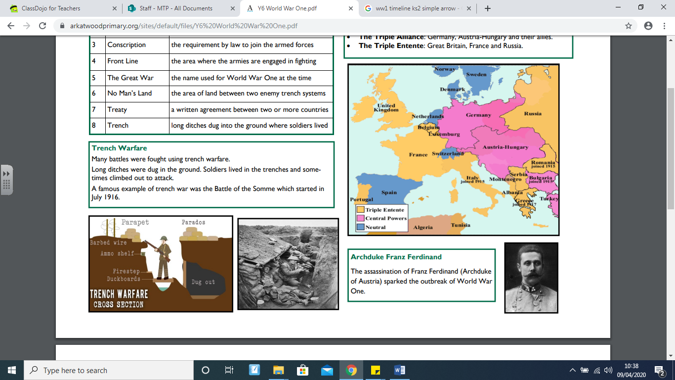

**Our Storytelling Approach to enhance engagement**

|  |  |  |
| --- | --- | --- |
| **People:**  Teenager | **Place:**  Trenches – Western Front | **Problem:**  Wants to go home |

**Focus Texts**

**Key Historical Facts**

|  |  |  |  |
| --- | --- | --- | --- |
| **Important Events and Life in World War One** | | | |
| Entangling Alliances |  | 1879-1914  The world’s most powerful countries formed alliances between each other – The Triple Entente (France, Britain and Russia) and the Triple Alliance (Germany, Austria-Hungary and their allies) | Key Fact:  Defence pacts between countries stated that in the event of war allied nations MUST aid an ally under attack. |
| Assassination of Archduke Franz Ferdinand | Did Franz Ferdinand's Assassination Cause World War I? - HISTORY | 28th June 1914  The Archduke and his wife Sophia were assassinated by Gavrilo Princip in Sarajevo, Bosnia. | Key Fact:  The Archduke had already survived one assassination attempt by the Black Hand Society that day. |
| July Crisis |  | July- August 1914  After Serbia’s failure to make amends after the assassination, Austria-Hungary (with an ally in Russia) declared war on them. Consequently, Germany declares was on Russia. By August 4th the European powers from the Allied and Central nations were at war. | Key Fact:  Britain was the last of the powers to declare war on 4th August 1914. |
| Trench Warfare | September 1914- November 1918 To prevent enemy advances, both sides built large trench systems which stretched from the North Sea through Belgium and France. As a result, neither side made much ground between 1914 and early 1918. Attacks involved crossing No Man’s Land which was open to heavy machine gun fire, mines and shelling. Life in the trenches was grim – disease, illness and death was rife. | | Key Fact:  Enemy trenches were between 50 and 250metres apart. |
| Gallipoli Campaign | Gallipoli Campaign | Summary, Map, Casualties, Significance ... | 19th February 1915 – 9th January 1916  An unsuccessful attempt by the Allied nations to control sea route from Europe to Russia. It included a failed Naval attack in February 1915 and a land invasion on 25th April which resulted in huge loses to the Ottoman Empire. | Key Fact:  Allies eventually evacuated in late December 1915 |
| Battle of the Somme | 1st July 1916 – 10th November 1916.  The largest battle in WWI took place on the Western Front. More than 3million soldiers fought in the battle with more than 1 million being killed or seriously injured. By the end of the battle the Allies had advanced 6km. | | Key Fact:  Battle is known for the first use of tanks as weaponry. |
| America Declares War | 6th April 1917. America declared war because Germany had broken the peace agreement to suspend warfare in the Atlantic Ocean and Mediterranean Sea –this caused U.S ships to be sunk by the German troops. | | Key Fact:  Arrival of US troop contributed to the turn of war in favour of the Allies. |
| Second Battle of Marne | 15th July – 6th August 1918. This was the last major German offensive attack during The Great War. They were defeated as the Allies counter-attacked. This triggered the Allies advance onto German territory which resulted in Armistice 100days later. | | Key Fact:  There were 168,000 German casualties during this battle. |
| Armistice Day | Poppy flower brooch round Poppy Brooch Pin Badge Remembrance Day ... | 11th November 1918 This signalled the end of fighting between the Allies and Germany. Previous Armistice has already been agreed with other central powers and it marked a victory for the Allies. | Key Fact:  The fighting officially ended at the 11th hour, on the 11th day of the 11th month in 1918. |
| The Treaty of Versailles | Treaty of Versailles | Definition, Summary, Terms, & Facts ... | 28th June 1919 The was the most important of the peace treaties designed to end World War I. It ended conflict between the Allied Powers and Germany. It was mainly discussed in Paris but officially signed in Versailles. The treaty made Germany accept full responsibility for the war and had to pay all affected countries huge amounts of money in compensation. | Key Fact:  Many believe that the treaty was too harsh on Germany and caused tensions between Germany and the Allies which eventually caused WW2. |

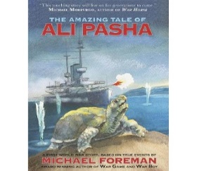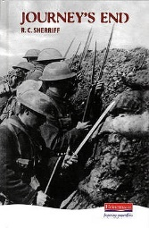

**Agreed Outcome**

Report on the horrors of trench life for the attention of David Lloyd George (PM)

We will Focus on Ali Pascha as well as reading extracts from the play script ‘Journey’s End’ and Owen’s and Sassoon’s poetry

|  |  |  |  |
| --- | --- | --- | --- |
| \\lyng-dc1\StaffShared\Learning Bugs Animals ALL subjects\characters bugs animals\Cyril the Snail - History.jpeg**Lyng Primary School Knowledge Quiz** | | | |
| **History Topic:** | **The Great War** | Year 6  *Civilisation, Communication and Inventions* | Summer Term |

|  |  |  |
| --- | --- | --- |
| 6. Wilfred Owen received… | **S** | **E** |
| No army training |  |  |
| Some army training |  |  |
| Lots of army training |  |  |

|  |  |  |
| --- | --- | --- |
| 7. The Battle of the Somme resulted in… | **S** | **E** |
| Britain and allies making advances |  |  |
| Germany making advances |  |  |
| Deadlock between the nations |  |  |

|  |  |  |
| --- | --- | --- |
| 8. The Battle of the Somme was unjust because…. | **S** | **E** |
|  |  |  |

|  |  |
| --- | --- |
| 9. List three types of warfare used in WWI. | |
| **S** | **E** |
|  |  |
|  |  |
|  |  |

|  |  |  |
| --- | --- | --- |
| 10. How did warfare improve over the cause of WWI? | **S** | **E** |
|  |  |  |

|  |  |  |
| --- | --- | --- |
| 1. Which country belonged to the Triple Entente? | **S** | **E** |
| 1. Austria-Hungary |  |  |
| 1. Germany |  |  |
| 1. Britain |  |  |

**Our WWI**

**Quick Quiz**

|  |  |  |
| --- | --- | --- |
| 1. Archduke Franz Ferdinand’s assassination was… | **S** | **E** |
| 1. For no reason |  |  |
| 1. Based on religious prejudice |  |  |
| 1. Political |  |  |

|  |  |  |
| --- | --- | --- |
| 1. Which main power was the last to join The Great War? | **S** | **E** |
|  |  |  |

**Start score:**

**End score:**

|  |
| --- |
| 1. What caused the outbreak of WWI? |
| S =  E = |